Setting Up Application Environment

**Setup Mobile Application Environment**

|  |  |
| --- | --- |
| Date | 15 November 2022 |
| Team ID | PNT2022TMID48441 |
| Project Name | CONTAINMENT ZONE ALERTING |

**Create An Android Application :**

Open Android Application:

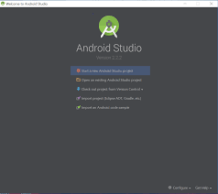

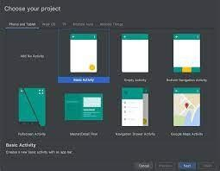

Select Basic Acitivity :

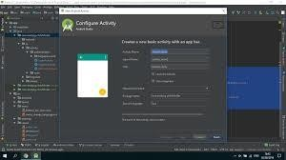

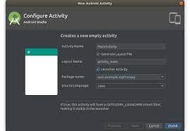

Language Set to JAVA :

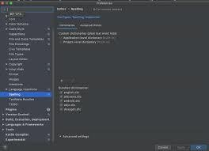

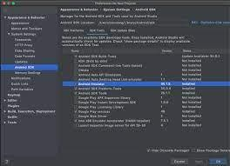

Click Finish :

